2020 HL Leaving Cert Physics Solutions

2020 Question 1
- Draw a labelled diagram of how the apparatus was arranged in this experiment.
Two trolleys/riders on track
Means of attachment
Timing device

- Describe how the time interval was measured.
If using a ticker tape time then the time intervals correspond to the number of gaps × 0.02 s.
Alternatively, the trolley could pass between a light gate and a detector and a timer measures the time the light source is blocked by the trolley.

- How were the effects of (a) friction and (b) gravity minimised?
Air cushion // track sloped
Horizontal track // frictional force = gravitational force / acceleration = 0 3 6
[“dust/polish runway” – maximum of 3 marks]

- Use the data to calculate the initial and final velocities of body A.
$velocity=\frac{displacement}{time}$ $u=\frac{0.114}{0.2}$ $v=\frac{0.061}{0.2}$ u = 0.57 m s⁻¹ v = 0.305 m s⁻¹

- Use the data to demonstrate how the experiment verifies the principle of conservation of momentum.
$$ρ=mv$$
Momentum of A = (0.1256 + 0.1111)(0.305) = 0.072 kg m s⁻¹

Momentum of B = (0.1256)(0.57) = 0.072 kg m s⁻¹

Momentum of A = Momentum of B

2020 Question 2
In an experiment to determine the refractive index of glass, light was passed through a glass block
and the angles of incidence i and refraction r were measured for different values of i.
The following data were recorded.
i (⁰) | 30 | 40 | 50 | 60 | 70 | 80
r (⁰) | 19 | 25 | 31 | 35 | 39 | 41

- Explain how the refracted ray and the angle of refraction were determined.
(A labelled diagram may help your answer.)
Using ray box / pins / laser the ray in the block is determined
Normal is drawn at point of incidence
Angle between the normal and the ray in the block is measured with a protractor

- Why would using a smaller angle of incidence have led to a less accurate measurement of the angle of refraction?
Smaller angle
Greater percentage error

- Use the data to draw a suitable graph to verify Snell’s law.
6 values of sin i and sin r calculated
Labelled axes
6 points plotted
Straight line with good fit

- Explain how your graph verifies Snell’s law.
The graph is a straight line through the origin

- Use your graph to calculate the refractive index of the glass.
$$slope=\frac{{y_{2}-y}_{1}}{{x_{2}-x}_{1}}$$
Correct substitution using two points – these have to be from the line itself.

Answer: refractive index = slope (assuming sin i went on the y axis) is approximately 1.5

2020 Question 3

- Draw a labelled diagram of how the apparatus was arranged in this experiment.
Air column and tuning fork
Means of adjusting the length of the air column
Correct arrangement

- How did the student determine the length of the air column for a particular frequency?
Hold a vibrating tuning fork over the air column
Change length of air column until loud sound is heard

- How did the student ensure that the fundamental frequency, not an overtone, was observed?
Start with a small length and increase length until first loud sound is heard.

- Use the data to draw a graph of f against ¹/l.
6 values of ¹/l calculated

- Calculate the slope of your graph.
$$slope=\frac{{y_{2}-y}_{1}}{{x_{2}-x}_{1}}$$

Correct substitution using two points – these have to be from the line itself.

Answer: refractive index = slope (assuming sin i went on the y axis) is approximately 85

- Hence or otherwise calculate the speed of sound in air.
v = f λ v = 340 m s⁻¹

2020 Question 4
- Name the pieces of apparatus that were used to measure (a) the diameter, (b) the length and (c) the resistance of the wire.
(a) Micrometer / vernier calipers / digital calipers
(b) Metre stick
(c) Ohmmeter / multimeter

- How did the student ensure that the diameter of the wire was uniform?
Measured diameter at different places on the wire / no kinks

- Use the data to draw a graph of R against l.
Labelled axes
6 points plotted
Straight line with good fit

- Calculate the slope of your graph.
Calculate the slope of your graph.
$$slope=\frac{{y_{2}-y}_{1}}{{x_{2}-x}_{1}}$$
Correct substitution using two points – these have to be from the line itself.
Approximate answer: slope = 0.34

- Hence calculate the resistivity of the metal.
$ρ=\frac{RA}{l}$ ρ =1.12 × 10⁻⁶ Ω m

- How would the resistance of a fixed length of wire change if its diameter was doubled?
$ρ=\frac{RA}{l}$ $R=\frac{ρl}{A}$ $R=\frac{ρl}{πr^{2}}$

Resistance is therefore proportional to $\frac{1}{r^{2}}$ so if the radius goes up by a factor of 2 (“doubles”) then the resistance goes down by a factor of 4 (gets 4 times smaller).

- Question 5

- State Boyle’s law.
For a fixed mass of gas at constant temperature, pressure is inversely proportional to volume

- What would the radius of the Earth be if it had the same density as the neutron star?
$density (ρ)=\frac{mass (m)}{volume (v)}$ $volume=\frac{mass}{density}$ $volume=\frac{{6.0×10}^{24}}{3.7 × {10}^{17}}$

$volume=\frac{{6.0×10}^{24}}{3.7 × {10}^{17}}$ = ${1.62×10}^{7}$ m³

$volume= {\frac{4πr}{3}}^{3}$ ${1.62×10}^{7}= {\frac{4πr}{3}}^{3}$ r = 157 m

- Calculate the natural length of the spring.
F = -k(extension)
2 = -50(0.22-l₀) where l₀ = natural length
Natural length = 18 cm

- Draw a ray diagram to show the formation of an image in a convex mirror.
Object and correct mirror
Two correct rays
Appropriate lines behind mirror and correct image

- What is meant by the amplitude of a wave?
Maximum displacement (from rest position)

- Name one of the three primary colours of light. What is its complementary colour?
Red and cyan// green and magenta // blue and yellow

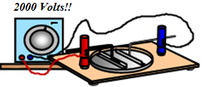
- Draw a labelled diagram to show how an electric field pattern can be demonstrated in the laboratory.
[−1 if “high” not mentioned]
Connected across plates, with oil, semolina

- Distinguish between intrinsic and extrinsic conduction in a semiconductor.
Intrinsic is through a pure semiconductor / intrinsic: equal number of holes and electrons
Extrinsic is through a doped semiconductor / extrinsic: excess of holes or electrons

- The diagram shows a sketch of a photocell.
a. What particles move between the electrodes of the photocell? Ans: electrons
b. In what direction do the particles move? Ans: from cathode to anode

- Write a nuclear equation to show the pair annihilation of a positron and an electron.
Or
Draw the truth table for an OR gate.
1 + 1 → 1; 1 + 0 → 1; 0 + 1 → 1; 0 + 0 → 0

2020 Question 6

- State Newton’s laws of motion.
A body remains at a constant velocity unless acted on by a force.
Force is proportional to the rate of change of momentum.
If object A applies a force to object B, object B applies an equal and opposite force to object A.

- Show that F = ma is a special case of Newton’s second law.
Force is proportional to the rate of change of momentum.
$force∝\frac{mv-mu}{t}$ $force∝\frac{m(v-u)}{t}$ F ∝ ma F = k (ma)

Note: k = 1 because of how we define the newton F = ma

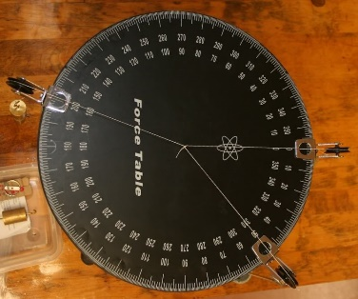
- Describe an experiment to find the resultant of two co‐planar vectors.
Use cord to attach three weights to a central knot using either a force-table with pulleys as shown or alternatively using three newton-meters.
Adjust the size and/or direction of the three forces until the central knot remains at rest.
Read the forces and note the angles.
Resolve any two of the forces to find out their components along the axis of the third force (see example above).
Add both of these components and they should add up to the same value as the third force.

- Use Newton’s laws of motion to explain why she moves her hands away from the motion of the ball.
Force is proportional to the rate of change of momentum.

So if the interaction takes place over a longer time it will result in a smaller force between hand and ball (making it easier to hold on to the ball).

- Calculate how long the ball was in the air
In the vertical direction:
s = 0
$$u=28\sin{45=}28√2$$
a = -9.8 m s⁻²
$s=ut+\frac{1}{2}$a$t^{2}$
Ans: t = 4.04 s

- Calculate the horizontal distance travelled by the ball
There is no acceleration in the horizontal direction so we can just use:
horizontal distance = (horizontal velocity)(time)
horizontal distance = ($28\cos{45}$)(4.04) = 80 m

- Calculate the maximum height above the ground reached by the ball.
s = ?
$$u=28\sin{45=}28√2$$
a = -9.8 m s⁻²
t = 2. 02 s (time to get to max height = ½ of total time)
$s=ut+\frac{1}{2}$a$t^{2}$
$$s=20 m$$
Total height above the ground = 20 + 1.6 = 21.6 m

- Draw a diagram to show the velocity v and acceleration a of the ball when it is at its maximum height. Also show the force(s) F on the ball.
v horizontal; a vertically down; F vertically down

2020 Question 7
- Describe how a pear‐shaped metal body can be charged by induction.
Bring charged body close to pear shaped conductor
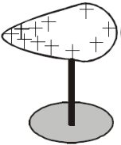
Connect the conductor to Earth
Remove the connection to Earth, then the charged body

- Draw a diagram to show the distribution of charge on the body after charging.
Charge throughout with concentration at the pointed end

- Define capacitance.
The capacitance of a conductor is the ratio of the charge on the conductor to its potential.


- Draw the circuit symbol for a capacitor.
See diagram
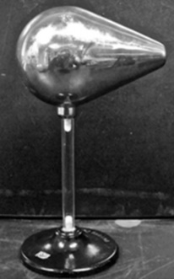

- Calculate the maximum rise in temperature of the water.

Energy lost by charged capacitor = energy gained by water
½ CV² = mcΔθ

½ (4000×10⁻⁶)(500)² = (0.04)(4180)(Δθ)
Δθ = 3⁰C

- Describe an experiment to demonstrate how the capacitance of a parallel‐plate capacitor changes with the distance between the plates.
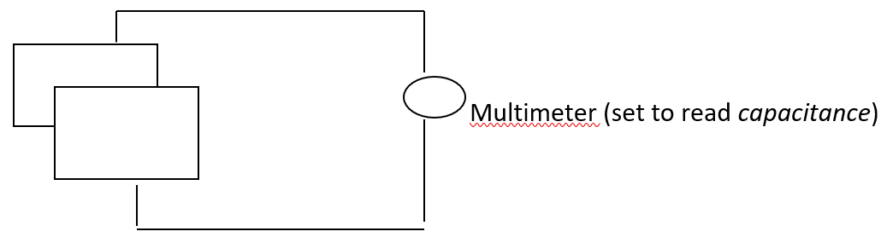

- Connect the two parallel plates to a multi-meter set to read capacitance. Note the capacitance.
- Increase the distance between them – note that the capacitance decreases.
- Move one plate slightly to the side (decreasing the overlap area) – note that the capacitance decreases.
- Place different slabs of insulating material between the plates – note that the capacitance is lowest when nothing (air) is between the plates*.

- Calculate the surface area of the inner cylinder of aluminium foil.
Surface area = 2πrh = 2π(0.06)(0.17) = 0.064 m²

- Calculate the capacitance of the Leyden jar.
ε = 8.85 × 10⁻¹² glass has a relative permittivity of 2.1 so its actual permittivity = (2.1)(8.85 × 10⁻¹²)

$C=ε\frac{A}{d}$ = $\frac{(2.1)(8.85 × {10}^{-12})(0.064) }{0.005}$ = 0.238 nF

- What property of glass allows it to be used as a dielectric?
Insulator

- Question 8

- Define radioactivity
Radioactivity is the (spontaneous) disintegration of a nucleus with the emission of one or more types of radiation. [−1 for “atom” instead of nucleus]

- Define the becquerel.
A becquerel corresponds to one disintegration per second

In the uranium decay series, U–238 decays to Pb206 in a series of alpha and beta decays.
The first decay in this series is an alpha decay and the final decay is a beta decay.

- Write a nuclear equation for the first decay in this series.
$${}_{92}^{238}U →{}_{2}^{4}{He+ {}_{90}^{234}{Th}}$$

- Write a nuclear equation for the final decay in this series.

$${}_{81}^{206}{Tl} →{}_{-1}^{0}{e+ {}_{82}^{206}{Pb}}$$

- Calculate the total number of alpha particles and the total number of beta particles emitted in the series

8 alpha and 6 beta

The half‐life of U–238 is 4.5 × 10⁹ years.
- How long will it take for the number of U-238 nuclei in a sample to decrease by a factor of 8?
3 half lives
1.35 × 10¹⁰ years

- A sample of U–238 contains 3.2 × 10¹⁰ nuclei. Calculate its activity.

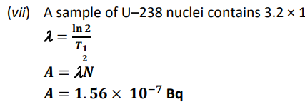

- What are isotopes?
Isotopes are atoms which have the same number of protons but different number of neutrons
Isotopes are atoms which have the same atomic number but different mass number.

- Why is radon considered to be dangerous?
It is radioactive and so can cause cancer.

- How can the build-up of radon in a building be reduced?
Sump / membrane / ventilation

2020 Question 9

- Define resonance.
Transfer of energy between two objects of the same natural frequency
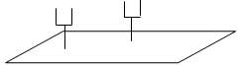
- Describe a laboratory experiment to demonstrate resonance.
- Use two identical tuning forks (same frequency) and a sound-board.
- Start one fork vibrating, place it on the sound-board and notice the sound.
- Place the second tuning fork on the sound-board and then stop the first tuning fork from vibrating.
- The second fork can now be heard.

- Draw a labelled diagram to show a guitar string vibrating at its fundamental frequency.
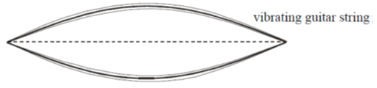
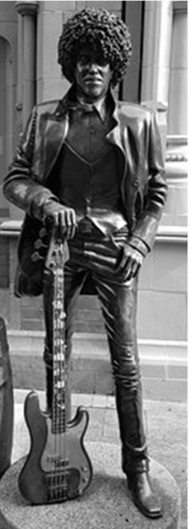
- Calculate the tension in the string
l = 0.651 m
f = 330 Hz
µ = $\frac{m}{l}= \frac{0.88×{10}^{-3}}{2}$
T =?

We need to rearrange the equation above to get T on its own:
⇒

4l²f² = $\frac{T}{µ}$ ⇒ $µ$ 4l²f² = T T = ($\frac{0.88×{10}^{-3}}{2}$)(4)(0.651)²(330)²

Answer:
T = 81 N

- Calculate the speed of sound in the string.
The length of the guitar string corresponds to half a havelength.
λ = 2(0.651) = 1.302 m
v = fλ = (330)(1.302) = 429 m s⁻¹

- Draw the magnetic field around a bar magnet.
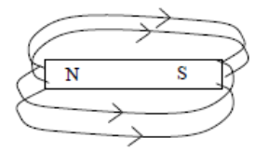
- Explain how an emf is induced in the coil.
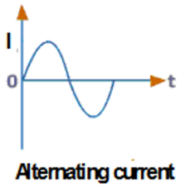
Moving coil
Changing magnetic field cutting the coil

- Sketch a graph to show how the output current varies with time.
See diagram

2020 Question 10

- What are the two fundamental forces that the neutrino experiences?
Weak, gravitational
- Pions and kaons are members of the meson family. What are mesons?
Quark and anti‐quark pair
- List the three types of neutrino in order of increasing mass.
Electron neutrino, muon neutrino, tau neutrino.
- Why is no tunnel required to transport the neutrinos underground to South Dakota?
Small mass / no charge / little interaction with matter because the planet is almost completely empty space.
- Calculate the time taken for the neutrino to travel from Fermilab to South Dakota.
$velocity=\frac{displacement}{time}$ $time=\frac{displacement}{velocity}$ $time=\frac{1300000}{(0.99)({3×10}^{8})}$ = 0.0044 secs

In another experiment in Fermilab two protons, each with a kinetic energy of 29 GeV, collide and new particles are created.
After the collision, the total kinetic energy of the two protons and the new particles is 16 GeV.
- Calculate the total mass of the new particles created.
Before the collision the total kinetic energy was 58 GeV. Afterwards it was 16 GeV.
So 42 GeV has been converted into mass energy.
How much mass? We need to use E = mc² to find out.
But before we do that we first need to convert the 42 GeV into joules.
42 GeV = (42×10⁹)(1.6×10⁻¹⁹) = 6.72 × 10⁻⁹ joules.
E = mc² $m=\frac{E}{c^{2}}=\frac{{6.72 × 10}^{-9}}{({{3 × 10}^{8)}}^{2}}$ = 7.48×10⁻²⁶ kg.

- What is nuclear fission?
Splitting of a large nucleus into smaller nuclei with the emission of energy and neutrons.
[−1 for “atom” instead of nucleus]
[−1 for omission of nuclear size]

- Why was Fermi’s nuclear reactor self‐sustaining?
Chain reaction / on average every fission caused another fission

- Graphite was used in his nuclear reactor. What was the purpose of the graphite?
To slow down fast neutrons / to increase the rate of fission / to act as a moderator

- Is nuclear fission a spontaneous or a non‐spontaneous process? Explain your answer.
Non‐spontaneous because a neutron is required to initiate the process.

2020 Question 10
- A moving‐coil galvanometer detects and measures small currents.
Describe, with the aid of a labelled diagram, the principle of operation of the galvanometer.
Coil, core, magnets, spring, pointer and scale 3
Current in coil 3
Coil experiences a force and rotates

- Draw labelled diagrams to show how a moving‐coil galvanometer can be converted into (a) an ammeter, (b) an ohmmeter.
(a) Low resistance 3
In parallel 3
(b) Variable resistor and power supply 3
In series

- A moving‐coil galvanometer has a full scale deflection of 50 mA and an internal resistance of 7.2 Ω. Calculate the resistance required to convert it into a voltmeter with full scale deflection of 10 V.
- LEDs can also indicate the flow of current.
What is an LED?
- Describe, with the aid of a labelled diagram, the principle of operation of an LED.
- LEDs are fragile. How can they be protected in a circuit?
- State two differences between LEDs and photodiodes

2020 Question 11

  - How are electrons (i) produced, (ii) deviated in a cathode ray tube?
(i) Heated cathode / thermionic emission (ii) Electric/magnetic fields

  - Calculate the maximum speed of an electron in the tube.
Potential energy lost = kinetic energy gained
QV = ½ mv²
(1.6×10⁻¹⁹)(4000) = ½ (9.1×10⁻³¹)(v²)
v = 3.75 ×10⁷ m s⁻¹

  - What pieces of apparatus can be used to demonstrate the diffraction of light in the laboratory?
Diffraction grating, light source, screen/spectrometer

  - Describe the principle of operation of any detector of nuclear radiation.
Ionisation 4
Correct valid detail e.g. producing current

  - Describe the Geiger‐Marsden experiment that used thin sheets of gold.
Zinc sulphide / fluorescent screen; alpha source; gold foil; vacuum
Flashes on screen / scintillations
Most alphas straight through / deviated slightly
A few alphas reflected
Atom mostly empty space
Small/dense positive core

  - Describe with the aid of a labelled diagram the Bohr model of the atom. Use the model to explain emission line spectra.
Nucleus
Electrons in different energy levels
Electrons given energy
Rise to higher energy level
Fall to lower energy level
Photon/light emitted

2020 Question 12
Answer any two of the following parts, (a), (b), (c), (d).

(a)
- Derive an expression
Centripetal force = gravitational force

$$\frac{mv^{2}}{r}=\frac{Gm_{1}m_{2}}{d^{2}}$$
v²
Cancel one ‘m’ from both sides to get

Now v = speed = distance/time.

⇒ ⇒

=
And finally, we cross-multiply to get

- Calculate the period of the Moon as it orbits the Earth.
$T^{2}=\frac{4π^{2}({{3.85×10}^{8})}^{3}}{(6.7×{10}^{-11})({6.0×10}^{24})}$

T = 2.37 ×10⁶ s
- Calculate the gravitational force exerted by the Moon on an astronaut of mass 80 kg when he is 250 km above the surface of the Moon.
$$F=\frac{Gm_{1}m_{2}}{d^{2}}$$

$F=\frac{(6.7×{10}^{-11})({6.0×10}^{24})(80)}{[({{3.85×10}^{8})+{(250×10}^{3})]}^{2}}$ F = 98.73 N

- Astronauts appear to be weightless when they orbit the Moon. Explain why.
Astronaut and spaceship have common acceleration / spaceship in freefall

(b)
- Radiation is one of three methods of heat transfer. What are the other two methods?
Conduction, convection

- Calculate the infra‐red energy that falls on 0.25 m² of Antarctica in 3 minutes.
Energy = 850×0.52×0.25×60×3 = 19890 J

- Calculate the number of infra‐red photons that fall on this area in this time.
Total energy falling =19890 J
But how much energy does one photon have?
E = hf = (${(6.6×10}^{-34})({15×10}^{12})$ = ${9.9×10}^{-21}$ J

So number of photons equals total energy divided by energy of one photon = $\frac{19890}{{9.9×10}^{-21}}$ = 2×10²⁴ photons

- Calculate the energy
$Density=\frac{mass}{volume}$ mass = (density)(volume) = (920)(170000) = 7.82 × 10¹⁴ kg

5% of 7.82 × 10¹⁴ = 0.391 × 10¹⁴ kg

mcΔθ + ml
(0.391×10¹⁴)(2900)(6-2) + (0.391×10¹⁴)(3.3 × 10⁵) = 2.67 ×10²⁰ J

(c)
- What is the Doppler effect?
Change of observed frequency due to relative motion between the source and the observer.
- Explain, with the aid of labelled diagrams, how the Doppler effect occurs.
Labelled non‐concentric circles
Source moves towards observer
Wavelength is shorter
Frequency is higher

- A source of sound approaches a stationary observer.
The source appears to have a frequency that is 20% greater than its frequency at rest.
Calculate the speed of the source.
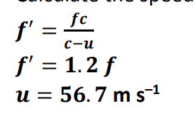

- What does the red‐shift tell us about the universe?
Universe is expanding

(d)
- What is current?
Current is defined as the flow of charge.
Technically I = Q/t, so current should be defined as the rate of flow of charge but for some reason the first definition has always been accepted.
Go figure.
- Calculate the current flowing when a mole (6.0 × 10²³) of electrons passes a point in 30 minutes.
Total charge = (charge of one electron)(number of electrons)
= (1.6 × 10⁻¹⁹)(6.0 × 10²³) = 96000 C
$$I=\frac{Q}{t}=\frac{}{}$$
=

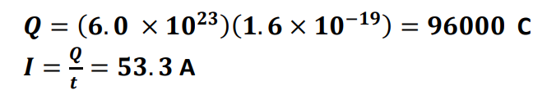
- Explain why this phenomenon occurs.
Each current carrying wire has a magnetic field and each wire experiences a force in the other’s magnetic field.

- Describe a laboratory experiment to demonstrate this phenomenon.
Power supply and U‐shaped foil
Allow current to flow
Foil moves

